1. Plot Lateral Force vs. Slip Angle for each Normal Load. Plots should be similar to those on pages 76-80 of RCVD. (You may place all curves on one plot if each curve is properly identified.) Submit the plot.

2.Determine the Cornering Stiffness of the tire at each Normal Load. Put these values in a table and plot Cornering Stiffness vs. Normal Load (one plot). Submit the table and the plot.

-------------------------

FZ (N) c (N/deg)

-------------------------

-222.4000 215.5001

-444.8000 396.4480

-667.2000 561.1762

-1112.0000 860.1163

-1556.8000 1035.5762

-------------------------

3.Determine the Friction Coefficient of the tire at each Normal Load in a left hand turn. Put these values in a table and plot Friction Coefficient vs. Normal Load (one plot). Submit the table and the plot.

----------------------

FZ (N) u

----------------------

-222.4000 2.9038

-444.8000 2.7952

-667.2000 2.6698

-1112.0000 2.5196

-1556.8000 2.3495

----------------------

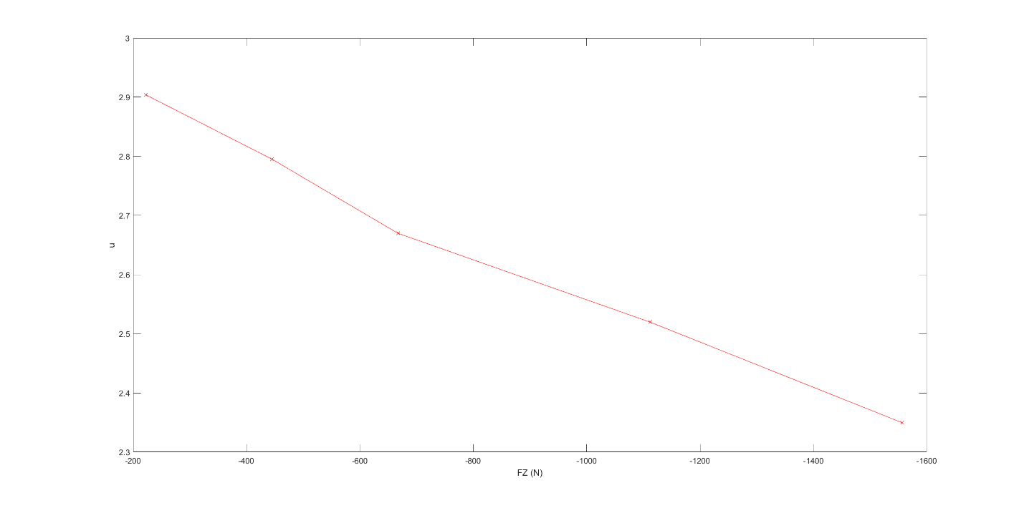

4.Plot Aligning Torque vs. Slip Angle for each Normal Load. Plots should be some what similar to that on page 30 of RCVD. (You may place all on one plot if each curve is properly labeled.) Submit the plot.

5.The first approximation in modeling the vertical behavior of a tire is to consider the tire simply as a spring. Determine the Vertical Spring Rate of the tire at zero Slip Angle, zero Inclination Angle and zero Lateral Force. To do this, begin by plotting Normal Load vs. Loaded Radius at this condition. The slope of this curve is the tire vertical spring rate. What is the spring rate at 200 lb Normal Load? Submit your plot and the value at 200 lb.

Vertical spring rate = 896.2001 N/cm @ FZ = 200 lbs. (Note: it will be same for a given tire at all loads, since spring is “supposed” to behave linearly with a constant spring rate).